State Anti-Bullying Laws

••..HI .
States with anti-bullying laws that include
cyber-bullying/ electronic harassment
II
States with anti-bullying laws
II

States without anti-bullying laws
II

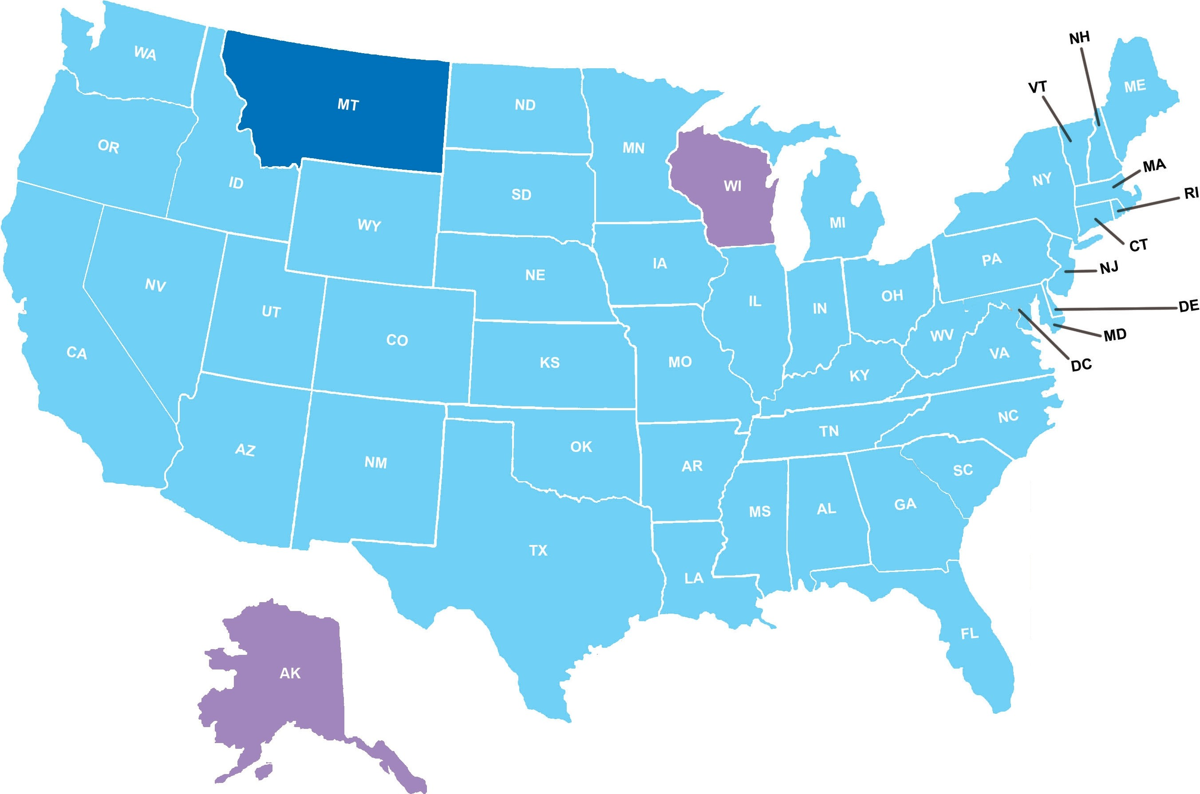•

October 2012

American Foundation
O
- · far Smc1de Prevent10n

